Gold Coast Convention & Exhibition Centre Showcases Sennheiser MobileConnect at Australian Assistive Technology Conference

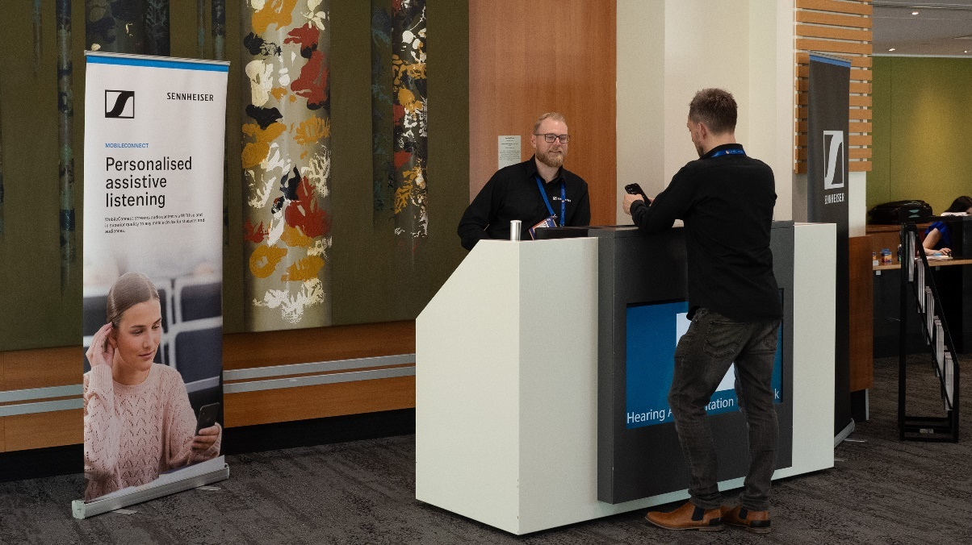

Gold Coast Convention and Exhibition Centre (GCCEC) completes a successful pilot of the Sennheiser MobileConnect system, bringing increased accessibility and inclusivity with cutting edge assistive listening technology during Australian Assistive Technology Conference.

Sydney, Australia, 4 December 2024 – The Gold Coast Convention & Exhibition Centre (GCCEC) recently stress tested its new Sennheiser MobileConnect system during the Australian Assistive Technology Conference 2024 run by the Australian Rehabilitation & Assistive Technology Association (ARATA), redefining how assistive listening solutions are delivered at large-scale events. Now a new key feature in the venue, this cutting-edge technology marks a major advancement in accessibility, combining usability, adaptability, and seamless integration into existing infrastructures.

Revolutionising Assistive Listening with Wi-Fi Technology

The MobileConnect system leverages attendees' personal devices to deliver an accessible and inclusive audio experience. The system shifts reliance away from traditional hearing induction loops and infrared-based technologies to Wi-Fi and Bluetooth. This expands the scope of assistive hearing beyond just compliance and aiding those with significant hearing impairments. It opens accessibility to broader audiences, including the neurodiverse, older adults, and anyone with a smart device who prefers to hear public broadcast audio through their personal ear or headphones.

As a result, MobileConnect harnesses this advanced connectivity to provide a robust, user-friendly solution for diverse needs.

Chris Davey, GCCEC’s Executive Manager of Technology, noted the importance of this shift, “induction loops often don’t last – they’re prone to damage, especially when embedded in carpets; and infrared systems struggle with connectivity and require a clear line of sight, which leads to frequent dropouts and user issues,” he continued, “We did evaluate all the various options at the Integrate Expo and remained focused on MobileConnect because of its usability, adaptability, and the way it integrates with our existing systems.”

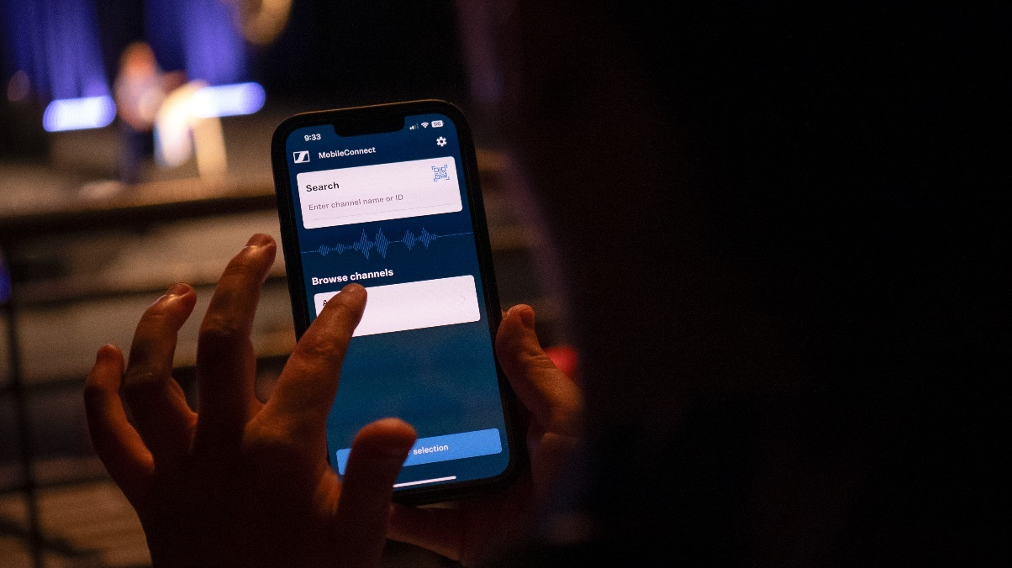
The MobileConnect user interface

An Accessible Future for All

The GCCEC’s successful piloting of the Sennheiser MobileConnect system is the culmination of its assistive hearing journey and the Australian Assistive Technology Conference provided the perfect debut opportunity. At the event GCCEC was able to showcase the system in full operation and also gather valuable expert feedback from delegates on its performance and user experience.

Libby Callaway, as Strategic Executive Advisor and past president of ARATA took a keen interest in GCCEC’s investment in assistive technology. In Callaway’s role with the association, as well as in her private practice as an occupational therapist, she specialises in improving the lives of clients with neurological issues; clients who very often have experienced hearing changes.

“The recent Disability Royal Commission highlighted the need for mainstream services to be accessible for and usable by people with disabilities,” observes Callaway. “With high representation of individuals with autism and intellectual disabilities in Australia, the kind of technology that Sennheiser MobileConnect represents could be invaluable. My hope is to see this type of technology available not just in exhibition centres or schools but in a whole variety of spaces allowing people who use hearing products, or have specific sensory preferences, to fully participate in public life.”

Seamless Integration and Usability

The MobileConnect system integrates with GCCEC’s state-of-the-art Wi-Fi and audio-over-IP infrastructure, including Dante and Q-SYS platforms. These integrations enable effortless routing and configuration, ensuring audio follows room reconfigurations seamlessly. With an easy two-step process for users—downloading the MobileConnect app and scanning a QR code—barriers to adoption are minimised.

Chris Davey shares, “MobileConnect dovetails nicely with our current systems. We have full Dante and Q-SYS integration, which means audio can be routed wherever needed and automatically adjusts as rooms change, making it seamless with MobileConnect. Having an API is also incredibly beneficial.”

More Than Compliance

MobileConnect’s potential extends beyond accessibility. From silent stages to sensory-friendly spaces and noise-sensitive applications, the system's versatility opens new avenues for event organisers.

“We see MobileConnect as a tool for innovation,” Davey added. “Its adaptability, including features like the MobileConnect’s TalkBack feature we can see this being a valuable enhancement for our clients, not having to pass microphones around for Q&A.”

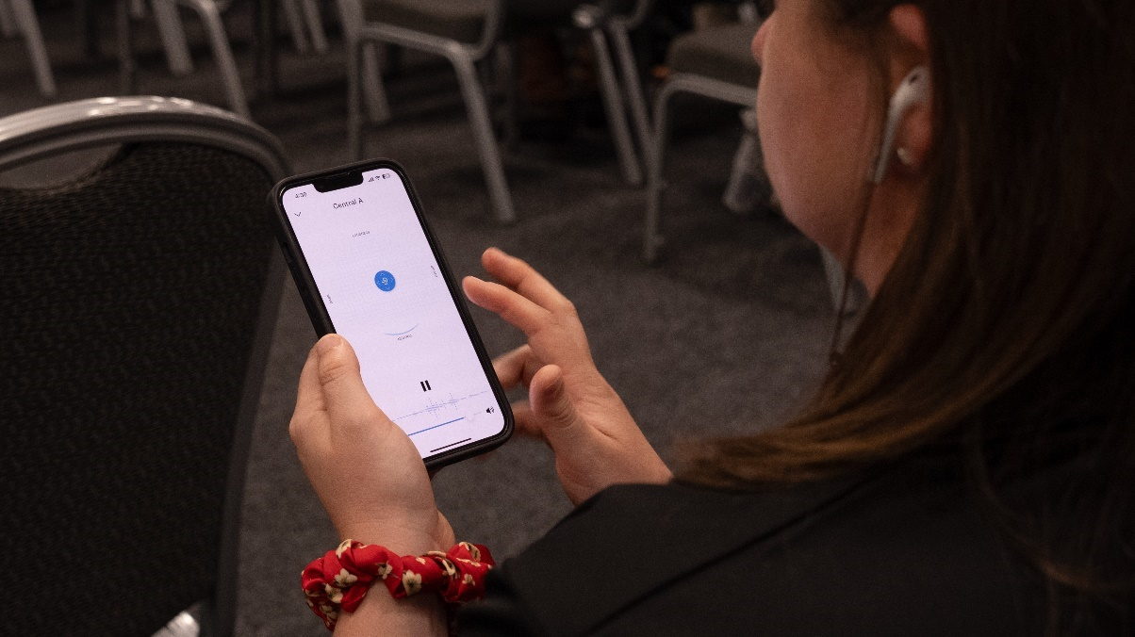
An attendee listening on their personal device

Redefining Standards of Inclusion

GCCEC’s adoption of MobileConnect reflects a forward-thinking approach to accessibility, shifting from mere compliance to delivering seamless, inclusive experiences. By setting a new benchmark for assistive listening technologies, the centre ensures its events are accessible, engaging, and enriching for all attendees.

To see more of Sennheiser’s solutions at the Gold Coast Convention & Exhibition Centre, see here.

###

About the Sennheiser brand

We live and breathe audio. We are driven by the passion to create audio solutions that make a difference. Building the future of audio and bringing remarkable sound experiences to our customers – this is what the Sennheiser brand has represented for more than 75 years. While professional audio solutions such as microphones, meeting solutions, streaming technologies and monitoring systems are part of the business of Sennheiser electronic GmbH & Co. KG, the business with consumer devices such as headphones, soundbars and speech-enhanced hearables is operated by Sonova Holding AG under the license of Sennheiser.

www.sennheiser.com
www.sennheiser-hearing.com

Local Press Contact  Kirsten Spruch  kirsten.spruch@sennheiser.com  +1 (860) 598-7484 | Hotwire Australia  sennheiseranz@hotwireglobal.com

